22.53: a) At
So:
b) 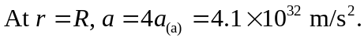
c) At 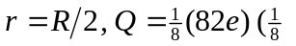because the charge enclosed goes like 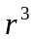) so with the radius decreasing by 2, the acceleration from the change in radius goes up by 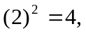 but the charge decreased by 8, so 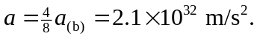
d) At 